**4 October 2024**

**HRH The Princess Royal meets unpaid carers at Carers Trust Conference**

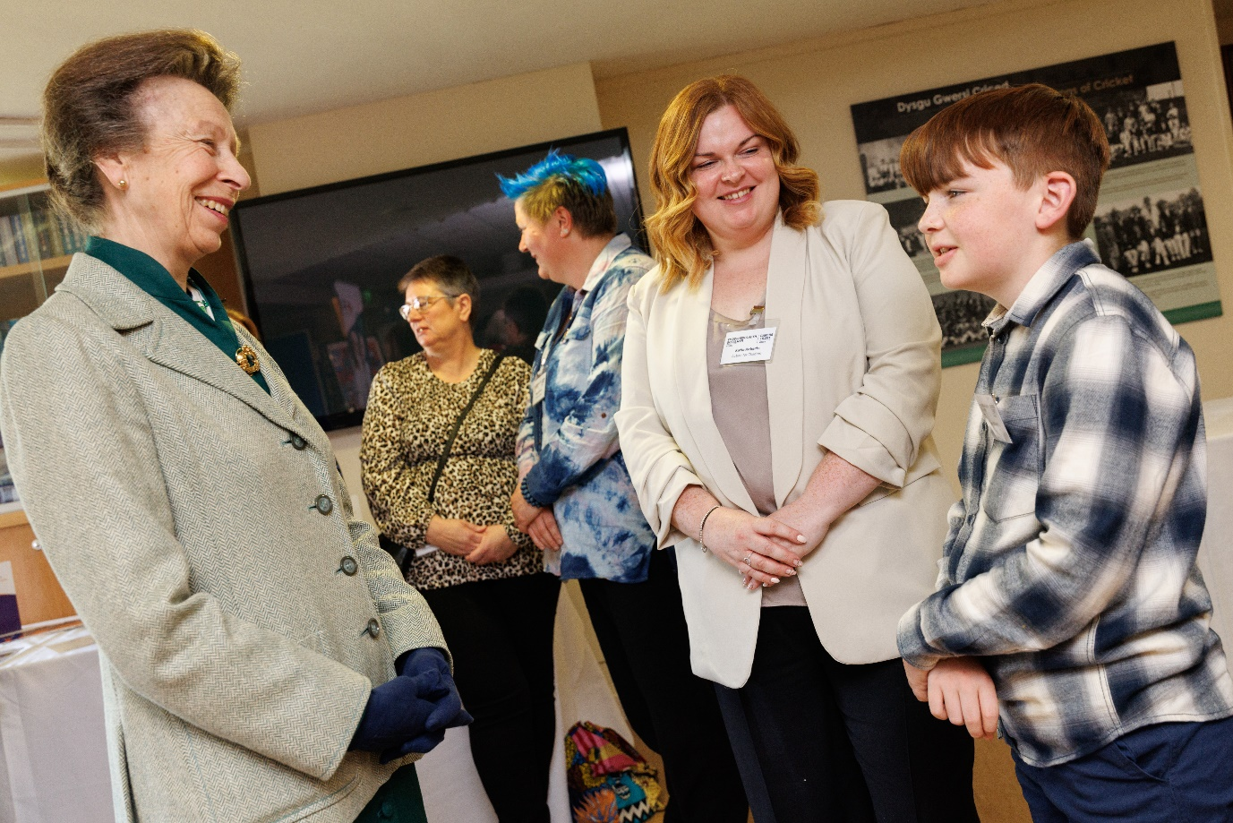

Photo caption: Carers Trust President, HRH The Princess Royal, meets unpaid carers and caring organisations from across Wales at the Short Breaks Conference in Cardiff.

Carers Trust President, HRH The Princess Royal, metunpaid carers and caring organisations from across Wales at the Short Breaks Conference on Thursday 3 October.

Caring organisations and unpaid carers attended the conference at the Glamorgan County Cricket Club in Cardiff, organised by Carers Trust Wales. The conference highlighted the impact of the Short Breaks Scheme, which has provided an opportunity for more than 13,000 unpaid carers to have a short break away from their caring role.

Kate Cubbage, Director Carers Trust Wales, says, “Unpaid carers play a vital role supporting family members, friends and neighbours. Our fragile health and social care system is reliant on the often selfless contribution of carers. I am delighted that our President, HRH The Princess Royal, met and spoke with many of the organisations delivering the Short Breaks Scheme, a scheme that is essential to sustaining carers in the crucial role they play in communities across Wales. Carers who have benefited from a short break also had the opportunity to meet with Her Royal Highness to share the difference taking a short break had made to them and those they care for.”

Kate continues, “There are over 310,000 unpaid carers in Wales. Their commitment is often unseen and undervalued. We welcomed the opportunity for HRH The Princess Royal to hear how the Short Breaks Scheme has made a bold start in helping to transform their lives.”

The Short Breaks Scheme is funded by Welsh Government and coordinated by Carers Trust Wales. It aims to supports 30,000 unpaid carers of all ages in Wales to take a break from their caring role, through overnight breaks, group activities and small grants by 2025.

Minister for Children and Social Care, Dawn Bowden said: “It was an honour to speak at the Carers Trust Short Breaks conference and hear from unpaid carers who have benefitted from our Short Breaks scheme. We highly value the vital role that unpaid carers play in our communities. Our £9m investment reflects our commitment to have additional opportunities for unpaid carers across Wales to take a break from their caring roles to maintain their physical and mental wellbeing.”

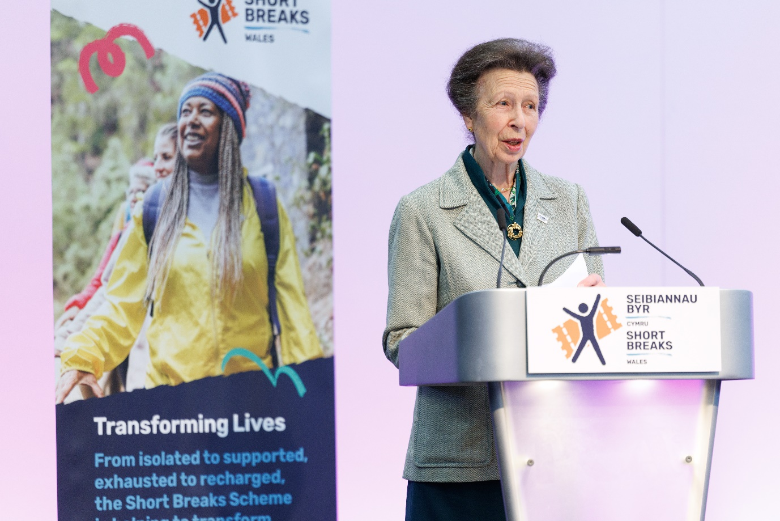

Carers Trust President, HRH The Princess Royal, addresses unpaid carers and caring organisations from across Wales at the Short Breaks Conference in Cardiff.

ENDS

**Notes to Editors**

**About Carers Trust Wales**

Carers Trust Wales, part of Carers Trust, aims to shape a better future with and for carers in Wales by raising awareness, empowering carers and influencing change. It is committed to making sure that all carers receive the recognition and support they deserve. It works closely and collaboratively with Network Partners – local and regional independent charities which deliver information, advice and practical support for unpaid carers in Wales.

Carers Trust website: [www.carers.org](http://www.carers.org)

**About the Short Breaks Scheme**

The Short Breaks Scheme is a new initiative launched in 2022 to support 30,000 unpaid carers from across Wales to take a much-needed break from their caring responsibilities. Funded by Welsh Government, it runs from 2022-2025. Carers Trust Wales is the National Coordinating body of the scheme, distributing grants to charities and Third Sector organisations across Wales.

With an overall budget of £9 million, management of the scheme is shared between Carers Trust Wales and seven Regional Partnership Boards. Organisations apply for the funding to deliver the activities.

Short Breaks Scheme website: [www.shortbreaksscheme.wales](http://www.shortbreaksscheme.wales)

**About Transforming Lives: Short Breaks Conference**

Transforming Lives is the inaugural short breaks conference hosted by Carers Trust Wales as part of the Short Breaks Scheme. Unpaid carers, local carer organisations, third sector and statutory partners are among the 200 delegates who will attend the conference on 3 October at Glamorgan Cricket Centre, Sophia Gardens, Cardiff.

**Spokespeople available for interview**

* Kate Cubbage, Director of Carers Trust Wales
* Unpaid carers who have experienced a short break through the Short Breaks Scheme (pre-record only)

**Contact: Jude Wood:** [**jwood@carers.org**](mailto:jwood@carers.org)**; Catrin Edwards:** [**cedwards@carers.org,**](mailto:cedwards@carers.org) **07791667005 for further information and to arrange interviews.**

