


Short Breaks Scheme helps over 600 unpaid carers in Rhondda Cynon Taf and Merthyr Tydfil
Interlink Rhondda Cynon Taf (RCT), in collaboration with Voluntary Action Merthyr Tydfil, piloted a project to ensure carers in some of the most deprived areas of Wales could access the Short Breaks Scheme.
The scheme, coordinated by Carers Trust Wales and funded by Welsh Government, provides an opportunity for unpaid carers across Wales to have a short break away from their caring role, to enjoy some time for themselves and to focus on their own well-being.
Carers Trust Wales has distributed funding to over 30 organisations to offer a variety of short breaks, groups activities and microgrants. However, with no carer centres in Rhondda Cynon Taf and Merthyr Tydfil, a different approach was required. Working with Interlink RCT, Carers Trust Wales allocated £80,000 of funding which was disseminated to 11 grassroots organisations across the region.
One organisation that received funding was Small Woods, a thriving community with a shared passion for UK woodlands. Its Short Breaks project, the Carer’s Programme, was made up of 10 nature-based sessions, delivered in Merthyr Tydfil and Rhondda Cynon Taf for both unpaid carers and those who they care for. Sessions were designed to provide an immersive experience in local green spaces, provide relief from the daily grind, encourage connection with nature and teach green skills to pass on to friends and family.
Elise Hughes, project officer at Small Wood says, "The project has stimulated some fantastic partnerships and made a real difference to carers’ lives." She continues, "It was lovely to see the groups connect with each other and form a natural bond. Participants frequently expressed how much they enjoyed this time, and felt calm and ready to take on the remainder of their day.”
One participant comments, "Things like this do really make difference, even if it's only that couple of hours and then it's just the togetherness, the talking about it."
Kate Cubbage, Director Carers Trust Wales, says, "This project ensured we helped fill a gap in carers' support in areas of Wales that have significant unmet need. The evidence is clear that the poorest areas of Wales are often exceptionally caring, with some of the highest percentage of unpaid carers within their communities. It was vital that we worked with partners in these areas to offer creative and impactful solutions. Feedback from both the funded organisations and carers has been extremely positive and we hope to continue to build on this early success."
Interlink RCT concludes, “ The success of this grant scheme is testament to the difference voluntary sector groups and organisations make in supporting unpaid carers in their vital role”.
Other organisations who received funding for this region via Interlink and the Short Breaks Scheme included Barnado's, Cancer Aid Merthyr Tydfil, Age Connects Morgannwg, Becca’s Besties, Behaviour Support Hub, Cwmparc Community Organisation, Café 50, Gelli Life for Living, Twyn Community Hub and Valleys Kids.
ENDS
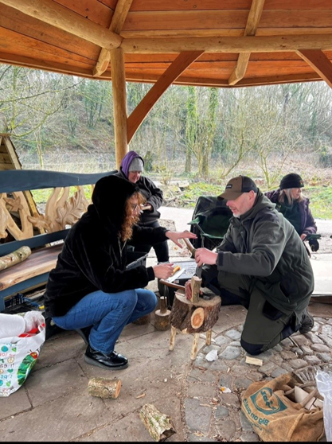
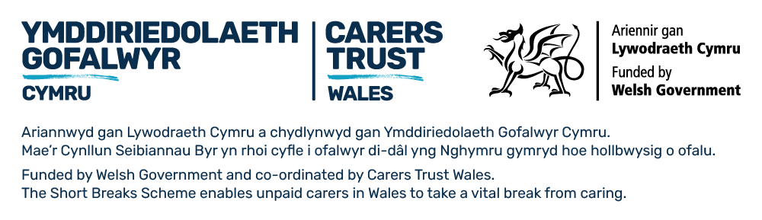
Sessions held by Small Woods in the round house in Rhondda Cynon Taf

Notes to Editors
About Carers Trust Wales

Carers Trust Wales, part of Carers Trust, aims to shape a better future with and for carers in Wales by raising awareness, empowering carers and influencing change. It is committed to making sure that all carers receive the recognition and support they deserve. It works closely and collaboratively with Network Partners – local and regional independent charities which deliver information, advice and practical support for unpaid carers in Wales.
Carers Trust website: www.carers.org

About the Short Breaks Scheme
The Short Breaks Scheme is a new initiative launched in 2022 to support 30,000 unpaid carers from across Wales to take a much-needed break from their caring responsibilities. Funded by Welsh Government, it runs from 2022-2025. Carers Trust Wales is the National Coordinating body of the scheme, distributing grants to charities and Third Sector organisations across Wales.

With an overall budget of £9 million, management of the scheme is shared between Carers Trust Wales and seven Regional Partnership Boards. Organisations apply for the funding to deliver the activities.

Short Breaks Scheme website: www.shortbreaksscheme.wales

About Interlink RCT
Interlink RCT is a members-led charity with over 550 community and voluntary organisations in Rhondda Cynon Taf. Our main activities cover:
- Community Advice – supporting groups with information, networking, peer support, training, events and funding.
- Volunteering – supporting volunteers and volunteer organisations.
- Wellbeing – supporting people to improve their health and wellbeing through community activities and local services.
- Working Together – supporting connections with public sector partners to value, develop and invest in preventative community activities and services.
Interlink RCT is the County Voluntary Council (CVC) for Rhondda Cynon Taf. Our members range from small community groups to larger charities. Website: Home - Interlink RCT English

Carers Trust Wales Contacts
Jude Wood: jwood@carers.org; Catrin Edwards: cedwards@carers.org

